

Cx/Re Routing Reaches Maximum Attempts
PITS 33007 & SEDL 8867
Test Plan

Hari Manchana, Ext. 7527

Table of Contents
Problem Description – SEDL 8867 3
Resolution 3
Test Case 1 – Original Order Cancellation at TE 3
Test Case 2 – Original Order Cancellation at PAR 4
Test Case 3 – Original Order Cancellation at OMT 5

Problem Description – SEDL 8867
When Cx/Re reaches maximum allowed re-routes because of failures, the orders i.e. cancel & replace orders gets cancelled automatically in the OHS but not at the destination i.e. TE or PAR

Resolution
Before automatically canceling the Cx/Re in the OHS, cancel the original order at the actual destination so that the original order (with full or remaining quantity) gets removed from TE Book or PAR Work Station.

Test Case 1 – Original Order Cancellation at TE

Test Procedure:
Set Cx/Re Re-route Attempts: Set Cx/Re re-route attempts to Zero (from default 5) on OHS by using below AR command on the BC where OHS is located.
ar OHServerHybrid testResetMaxRouteCounter -cancelReplaceReroute 0
Enter order: Buy 50@16.50, Br:Seq - ATG:1, Origin: C & Contingency: None
Verification:
Verify that Order (ATG:1) is in the TE Book.
Cx/Re order: From the TGU Order Status window, Cancel/Replace the above order with Br:Seq - ATG:2
Verifications:
- Verify that Order (ATG:1) is removed from the TE Book.
- Verify that cancelled quantity is updated for both Cancel (ATG:1) and Replace(ATG:2) orders in the TGUI Order Status window.
- Verify that HD has received following four messages for Cx/Re rejection, Original Order cancellation at the destination, Cancel and Replace orders cancellation at OHS.
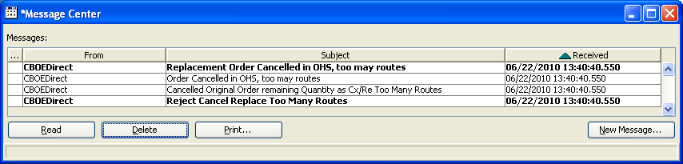

Test Case 2 – Original Order Cancellation at PAR

Settings/Pre-requisites:
Routing Properties:
Configure PAR destination W080 for the trading class.
Test Procedure:
Set Cx/Re Re-route Attempts: If this is not done in Test Case 1, set Cx/Re re-route attempts to Zero (from default 5) on OHS by using below AR command on the BC where OHS is located.
ar OHServerHybrid testResetMaxRouteCounter -cancelReplaceReroute 0
Enter order: Buy 50@16.50, Br:Seq - ATG:3, Direct Route: W080 Origin: C & Contingency: None
Verification:
Verify that Order (ATG:3) is at PAR W080.
Cx/Re order: From the TGU Order Status window, Cancel/Replace the above order with Br:Seq - ATG:4
Verifications:
- Verify that Order (ATG:3) is removed from PAR.
- Verify that cancelled quantity is updated for both Cancel (ATG:3) and Replace(ATG:4) orders in the TGUI Order Status window.
- Verify that HD has received following four messages for Cx/Re rejection, Original Order cancellation at the destination, Cancel and Replace orders cancellation at OHS.

Test Case 3 – Original Order Cancellation at OMT

Settings/Pre-requisites:
Routing Properties:
Configure HD OMT destination HOMT1 for the trading class.
Test Procedure:
Set Cx/Re Re-route Attempts: If this is not done in Test Case 1, set Cx/Re re-route attempts to Zero (from default 5) on OHS by using below AR command on the BC where OHS is located.
ar OHServerHybrid testResetMaxRouteCounter -cancelReplaceReroute 0
Enter order: Buy 50@16.50, Br:Seq - ATG:4, Direct Route: HOMT1 Origin: C & Contingency: None
Verification:
Verify that Order (ATG:4) is at OMT HOMT1.
Cx/Re order: From the TGU Order Status window, Cancel/Replace the above order with Br:Seq - ATG:5
Verifications:
- Verify that cancelled quantity is updated for both Cancel (ATG:4) and Replace(ATG:5) orders in the TGUI Order Status window.
- Verify that HD has received following four messages for Cx/Re rejection, Original Order cancellation at the destination, Cancel and Replace orders cancellation at OHS.
- Known Limitation: In this case, the OMT window is not updated for cancelled quantity as Order is already cancelled at the OHS. This is a known limitation because of OMT design but when OMT user tries to do Cx or Cx/Re, appropriate error message is displayed and when OMT logs out and logs back in, the cancelled quantity is correctly updated.

